Lab 1
Packet Tracer – Help, Navigation Tips & Network Representation
Topology
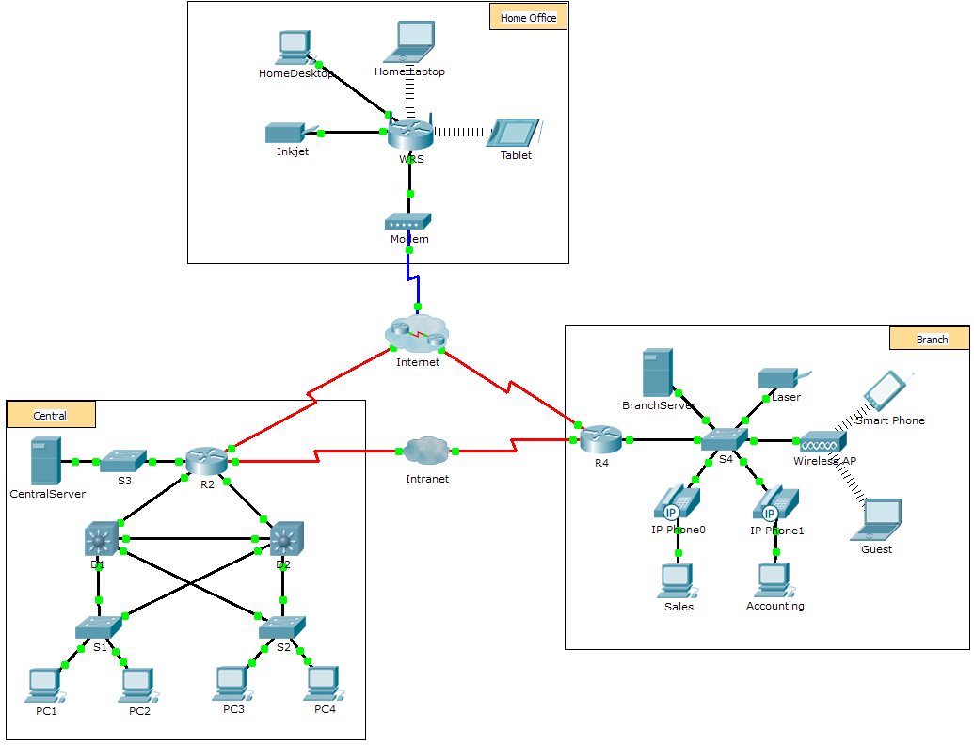

Background
Packet Tracer is a fun, take-home, flexible software program which allows you to experiment with network behavior, build network models, and ask "what if" questions.
The network model in this lab represents a simplified version of how a small to medium-sized business network might look and you will explore a few of Packet Tracer’s features. While doing so, you will learn how to access Help and the tutorials. You will learn how to switch between various modes and workspaces. You may need to adjust the window size of Packet Tracer to see the full network.
Note: It is not important that you understand everything you see and do in this lab. Many of the steps below will be covered in more depth as we progress in the module. You are strongly encouraged to familiarize yourself with acronyms such as LAN, WAN, DHCP, DNC etc. Feel free to explore the network on your own. If you wish to proceed more systematically, follow the steps below. Answer the questions to the best of your ability.
Step 1: Access the Packet Tracer Help pages, tutorial videos, and online resources
    - Access the Packet Tracer Help pages in two ways:
- Click the question mark icon in the top, right-hand corner of the menu toolbar.
- Click the Help menu, and then choose Contents.
    - Access the Packet Tracer tutorial videos by clicking Help > Tutorials. These videos are a visual demonstration of the information found in the Help pages and various aspects of the Packet Tracer software program. Before proceeding with this activity, you should gain some familiarity with the Packet Tracer interface and Simulation mode.
      - View the Interface Overview video in the Getting Started section of Tutorials.
      - View the Simulation Environment video in the Realtime and Simulation Modes section of Tutorials.
    - Find the “Configuring Devices Using the Desktop Tab” tutorial. Watch the first part of the tutorial and answer the following question: What information can you configure in the IP Configuration window?

Step 2: Toggle between Realtime and Simulation modes.
    - Find the word Realtime in the bottom right corner of the Packet Tracer interface. In Realtime mode, your network is always running like a real network, whether or not you are working on the network. Your configurations are performed in real time, and the network responds in near real time.
    - Click the tab directly behind the Realtime tab to switch to Simulation mode. In Simulation mode, you can watch your network run at a slower pace, observing the paths that data takes, and inspecting the data packets in detail.
    - In the Simulation Panel, click Auto Capture / Play. You should now see data packets, represented as envelopes of various colors, traveling between the devices.
    - Click Auto Capture / Play again to pause the simulation.
    - Click Capture / Forward to step through the simulation. Click the button a few more times to see the effect.
    - In the network topology on the left, click one of the envelopes on an intermediary device and investigate what is inside. See if you can answer the following questions:
- Under the OSI Model tab, how many In Layers and Out Layers have information?
- Under the Inbound PDU Details and Outbound PDU Details tabs, what are the headings of the main sections?

- Click back and forth between the Inbound PDU Details and Outbound PDU Details tabs. Do you see information changing? If so, what?
________________________________________________________________________________
________________________________________________________________________________
    - Click the toggle button above Simulation in the bottom right corner to return to Realtime mode.
Step 3: Toggle between Logical and Physical views.
    - Find the word Logical in the top left corner of the Packet Tracer interface. You are currently in the Logical workspace where you will spend the majority of your time building, configuring, investigating, and troubleshooting networks.
Note: Although you can add a geographical map as the background image for the Logical workspace, it does not usually have any relationship to the actual physical location of devices.
    - Click the tab below Logical to switch to the Physical workspace. The purpose of the Physical workspace is to give a physical dimension to your Logical network topology. It gives you a sense of scale and placement (how your network might look in a real environment).
    - Click the toggle button below Physical in the top right corner to return to the Logical workspace.
Step 4: Identify common components of a network as represented in Packet Tracer.
    - The icon toolbar at the bottom left hand corner has various categories of networking components. You should see categories that correspond to intermediary devices, end devices, and media. The Connections category (with the lightning bolt icon) represents the networking media supported by Packet Tracer. There is also an End Devices category and two categories specific to Packet Tracer: Custom Made Devices and Multiuser Connection.
    - List the intermediary device categories.
    - Without entering into the Internet cloud or Intranet cloud, how many icons in the topology represent endpoint devices (only one connection leading to them)?
    - Without counting the two clouds, how many icons in the topology represent intermediary devices (multiple connections leading to them)?
    - How many end devices are not desktop computers?
    - How many different types of media connections are used in this network topology?
Step 5: Explain the purpose of the devices.
    - In Packet Tracer, only the Server-PT device can act as a server. Desktop or Laptop PCs cannot act as a server. Based on your studies so far, explain the client-server model.
    - List at least two functions of intermediary devices.
    - List at least two criteria for choosing a network media type.
Step 6: Compare and contrast LANs and WANs.
    - Explain the difference between a LAN and a WAN. Give examples of each.
    - In the Packet Tracer network, how many WANs do you see?
    - How many LANs do you see?

The lab work is part of ‘Help and Navigation Tips ‘and ‘Network Representation’ activities from Cisco CCNA course. © 2019 Cisco and/or its affiliates. All rights reserved.

